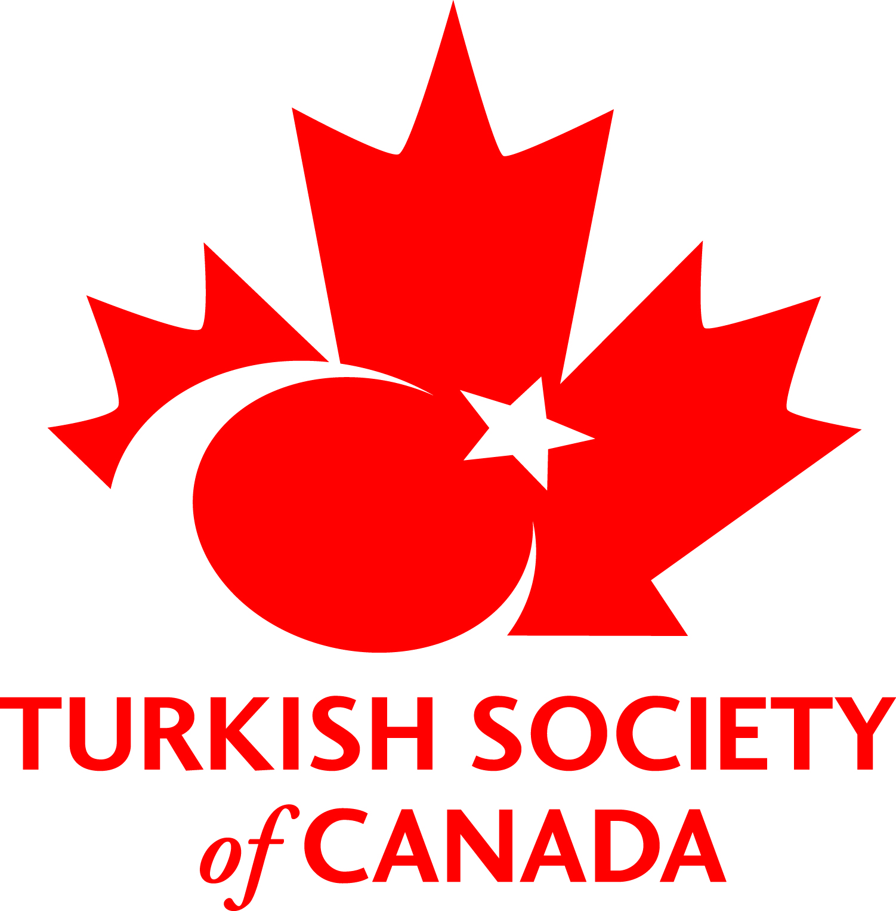
International Children’s Day-Multicultural Dance and Art Festival 2016
Sponsorship Registration Form

Sponsorship Categories:

Platinum Sponsorship = $ 1,000
Gold Sponsorship = $ 500
Silver Sponsorship = $ 300
Bronze Sponsorship = $ 150

For sponsorship eligibility, all contributions must be received by March 20, 2016.

Please fill out the form below, make your cheque payable to "Turkish Society of Canada", and send it enclosed in a sealed envelope to:

5100 Erin Mills Parkway
PO Box 53060
Mississauga
Ontario L5M 5H7

Company Name:
Company Mailing Address:
Company Telephone Number:
Representative Name:
Representative Mailing Address:
Representative E-mail Address:
Representative Telephone Number:
Sponsorship Levels: | Platinum | Gold | Silver | Bronze
Payment: $
Payment Method: | Cheque

